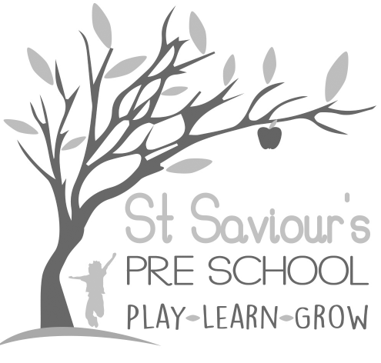
6.2 MANAGING CHILDREN WHO ARE SICK, INFECTIOUS, OR WITH ALLERGIES.

Written by: Claire Toms and Tina Alder Date: 1.09.22. – reviewed 08.10.24.

Policy statement

We aim to provide care for healthy children by preventing cross-infection of viruses and bacterial infections and promoting health through identifying allergies and preventing contact with allergenic triggers.
St. Saviour’s Pre-school and Nursery cannot guarantee a completely allergen-free environment, but we aim to minimise the risk of exposure, encourage self-responsibility in children where appropriate, and plan for effective responses to any emergencies.
St. Saviour’s is committed to no food or drink sharing.
The Statutory Framework requires that the provider must obtain and keep updated information about any dietary requirements or allergies. Parents are asked to provide details of allergies in the child’s Registration Form, submitted before starting Pre-school.

Procedures for children who are sick or infectious
- If children appear unwell during the day – e.g., temperature, vomiting, diarrhoea, or severe discomfort – the manager or the child’s key person will call parents/carers to collect the child immediately or request a known carer to do so.
- A child who is ill will be given a private area with a mattress and cover if they need to rest. The parent/carer will be contacted, and an adult stays with the child until they arrive.
- The child’s temperature is taken using a thermometer stored in the first aid box.
- In extreme cases, an ambulance will be called, and parents informed immediately.
- Parents may be asked to consult their GP before the child returns to the setting. We can refuse admission if the child has a temperature, diarrhoea, vomiting, or a contagious infection.
- Where antibiotics are prescribed, children should remain at home for at least 48 hours before returning.
- After diarrhoea or vomiting, children should remain at home for 48 hours following the last episode.
- In the event of two or more children experiencing food poisoning, Ofsted will be informed.
- There is no requirement to test for Covid-19, but if tested positive, children should remain at home for 3 days and only return if well enough.
PLEASE BE CONSIDERATE: DO NOT SEND CHILDREN TO THE SETTING IF THEY ARE DISPLAYING SYMPTOMS OF ILLNESS, unless it is a mild cold or teething.

Reporting of Notifiable Diseases
- If a child or adult is diagnosed with a notifiable disease under the Health Protection (Notification) Regulations 2010, the GP will report it to Public Health England.
- When we are formally informed, the manager contacts Ofsted and Public Health England and follows all advice given.

Nits and Head Lice
- Nits and head lice are not excludable conditions, but parents may be asked to keep the child away until treated.
- On identifying cases, all parents are informed confidentially.

Procedures for Children with Allergies / Anaphylaxis
Risk Management:
- Effective risk management practices are implemented to minimise exposure of children, staff, parents, and visitors to known allergenic triggers.
- Staff receive training in the identification and emergency response to allergic reactions.

Parents’ Role
Parents must provide accurate and up-to-date medical information in writing, including:
- The allergen (substance) the child is allergic to
- The nature of the allergic reaction (rash, breathing difficulties, anaphylaxis, etc.)
- Action plan for treatment, including medication and administration instructions
- Control measures to prevent contact with the allergen
- If a child requires an EpiPen, a signed healthcare plan must be completed before attendance.
- Parents must provide up-to-date medication clearly labelled; life-saving medication must be present at all times for attendance.
- Parents should provide at least two emergency contact details.
- Lunches brought from home must be safe for the child, and snacks provided by the setting may require parent consultation.

Staff Role
Staff responsibilities include:
- Familiarising themselves with this policy and adhering to food safety regulations.
- Ensuring healthcare plans are in place before a child starts if an allergy is identified.
- Holding team meetings to review severe allergies and update staff knowledge.
- Making all relevant staff aware of treatment plans and medication storage.
- Promoting handwashing before and after eating.
- Monitoring snacks and lunchtime foods to minimise allergen exposure.
- Cleaning tables with approved disinfectant solutions.
- Ensuring children do not share food.
- Staff training includes EpiPen use and storage.
- Emergency medication is easily accessible, especially during high-risk activities.
- Liaising with parents on snacks and food-related activities.

Actions in the Event of an Allergic Reaction
- Person 1 places the child in a comfortable, quiet space, administers antihistamine if appropriate, and reassures the child.
- Person 2 retrieves the EpiPen.
- Person 3 calls 999 (ambulance) and contacts the parent/carer.
- Person 1 administers EpiPen as directed, records time on paper, and stores used syringe safely.
- Keep the child warm and calm until the ambulance arrives.
- Inform ambulance staff of time of injection and healthcare plan details.
- Child is accompanied to hospital by parent or designated practitioner.

Role of Other Parents
- Lunches/snacks brought from home should be peanut and nut free.
- The preschool reminds parents regularly and monitors lunchbox contents to ensure safety.

